Binary Search

1) Idea
A searching method that repeatedly halves the search interval in a sorted collection to locate a target or determine the best position that satisfies a rule.
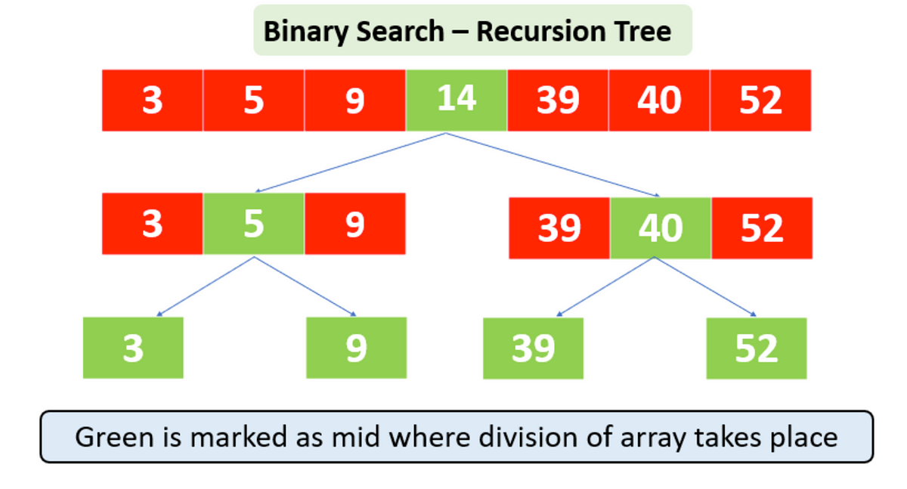

2) When it is useful
- Data is sorted
- Need to find an element or boundary
- Condition behaves monotonically, meaning once it becomes true or false it stays that way
Common goals:
- find an element
- first or last occurrence
- smallest or largest valid value
- lower or upper bound
- search within an answer range

3) Complexity
- Time: O(log n)
- Extra space: O(1) for iterative approach, O(log n) if recursion uses call stack

4) Recognition hints
If you see:
- sorted array
- words like minimum, maximum, first, last
- need faster than linear
- search in a numeric range such as capacity or speed
Binary search is usually the trick.

5) Basic template (iterative)
int left = 0, right = n - 1;

while (left <= right) {
int mid = left + (right - left) / 2;

if (nums[mid] == target) {
return mid;
} else if (nums[mid] < target) {
left = mid + 1;
} else {
right = mid - 1;
}
}

return -1;

6) Boundary style template
Used for first true or minimum valid answer.
int left = low, right = high;

while (left < right) {
int mid = left + (right - left) / 2;

if (condition(mid)) {
right = mid;
} else {
left = mid + 1;
}
}

return left;

problems
Easy
• Binary Search 704
• First Bad Version 278
• Search Insert Position 35

Medium
• Find First and Last Position of Element in Sorted Array 34
• Search in Rotated Sorted Array 33
• Find Peak Element 162
• Koko Eating Bananas 875
• Capacity To Ship Packages Within D Days 1011

Hard
• Median of Two Sorted Arrays 4
• Split Array Largest Sum 410

